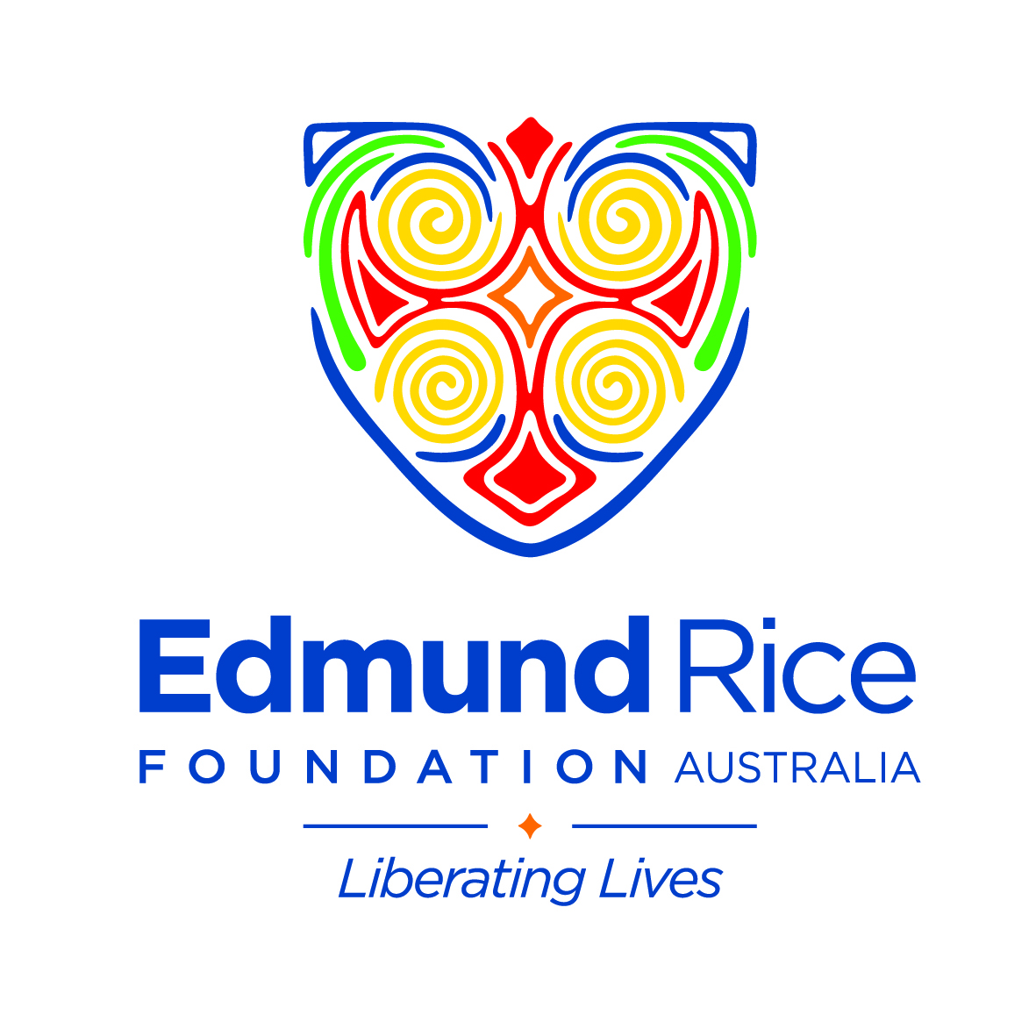
PROGRAM FUNDING ANNUAL ACQUITTAL REPORT
Australian Programs
For Calendar Year ended 31 December 2017

INSTRUCTIONS
- Throughout this template, ERFA refers to Edmund Rice Foundation Australia
- The Annual Acquittal Report is to be completed at the end of the funding cycle, which for ERFA normally follows the calendar year
- Please complete all sections of this template and respond to items as objectively as possible as your evaluation should inform your continuous improvement and program management
- Expand the boxes or add extra cells if needed
- For enquiries regarding the lodgement date for Annual Acquittal Reports, contact ERFA Compliance Officer at ERFAreports@edmundrice.org
- Completed Annual Acquittal Report and accompanying documentation to be forwarded to:
ERFAreports@edmundrice.org

WHY YOU NEED TO ACQUIT
The acquittal process involves an evaluation to assess whether a program achieved its objectives and delivered what was expected according to the original plan in the Program Funding Application.

Effective program evaluation facilitates:
- Assessment of program effectiveness
- Identification of strengths & weaknesses
- Discernment of strategies for continuous improvement
- Identification of where training is required
- Generation of new knowledge to inform decision making re program development
- Quality control for public accountability for ERFA funds expended
- Informed decision making by ERFA re continued funding

EVALUATION PRINCIPLES
The items in this template are intended to enable you to engage in an evaluative analysis of your program, using the following criteria: effectiveness, impact, efficiency & sustainability.

CONTENTS
Part A Program Details
Part B Financial Reporting
Part C Program Evaluation
Part D Risk Management
Part E Recognition of ERFA
Part F Feedback for ERFA

PART A: PROGRAM DETAILS
Name of Program Date Acquittal Report completed
DD / MM /YYYY

Location

This Report Prepared by (Full Name) Position / Role

PART B: FINANCIAL REPORTING
B1 Financial Reporting to ERFA

Please attach a copy of your program’s Financial Operating Statement as at 31 December.

Financial Operating Statement as at 31 December attached: YES NO

If NO, please indicate when your Financial Operating Statement as at 31 December will be provided:

B2 Independent Auditor’s Report
Please respond to the items below as relevant for your program.

Is your program governed directly by Oceania Province? YES NO

If YES, Oceania Province will advise ERFA of any concerns arising from the independent audit of your program. You do not need to provide ERFA with an auditor’s report.

Is your program independently incorporated? YES NO

If YES, please indicate below when you expect that your annual financial report will be available on the ACNC website:

(Please note: independent auditors must be accredited and must not be an employee of or be related to the program)

PART C: PROGRAM EVALUATION
C1 Program Effectiveness (Quantitative Evaluation)
(The extent to which program activities were delivered as planned and for the intended numbers of participants and on schedule)

Respond to each of the items below.

C1.1
To what extent were your program activities delivered as planned and on schedule?

C1.2
Were there any activities that worked better than expected or did not work as well as expected? Why? / Why not?

C1.3
Is there anything you would do differently in future? If so, please outline.

C1.4
Were there any significant variations from the original program plan as provided in your funding application? If so, please outline.

C1.5
To what extent were the intended numbers of program participants reached?

C1.6 Profile of Program Participants
In the table below, indicate the total numbers of program participants for each group for the year.

Gender / Age | Totals
Girls
Boys
Women
Men

C2 Program Impact (Qualitative Evaluation)
(Success of the program in achieving positive impacts, improving the quality of the lives of program participants)

Respond to each of the items below.

C2.1
What has happened as a result of your program’s activities? What real differences have your program activities made in the lives of program participants?

C2.2
Which program activity you would rate as the most successful in achieving program objectives and why?

C2.3
Did you observe any unintended consequences from program activities? If so, please describe the unintended consequences and actions taken.

C3 Program Efficiency
(How well were program resources (personnel & physical resources) utilized effectively to achieve program objectives?)

Respond to each of the items below:

C3.1
How effective would you rate your deployment and utilization of available program personnel and physical resources?

C3.2
Did you run a cost-efficient program? Have you discovered any alternative ways to achieve any of the same results at less cost?

C3.3
What areas would have the highest priority for additional personnel and / or resources if funds were available?

C4 Program Sustainability
(Evaluation of progress towards establishing program sustainability and viability beyond ERFA support)

Respond to the item below.

C4.1 Program Financial Sustainability
What progress was made during 2017 towards securing your program’s medium and longer term financial sustainability? Have any additional or alternative funding sources been identified?

PART D: RISK MANAGEMENT
D1 Identified Risks
Did any of the risks identified in the Risk Management Framework submitted with your Funding Application actually occur? If yes, indicate what risks were encountered and what mitigating actions were taken.

D2 Unanticipated Risks
Were any new and unanticipated risks encountered? If yes, indicate what these risks were and what mitigating actions were taken.

PART E: RECOGNITION OF ERFA
IE Recognition of ERFA
Please report below on how you have acknowledged ERFA publicly during the past 12 months

PART F: FEEDBACK FOR ERFA
F1 Feedback for ERFA
Do you have any feedback or suggestions you would like to provide to ERFA regarding any of the following?
- The Funding Application process
- The Quarterly Reporting process
- The Annual Acquittal process
- Any other aspects of your program’s working relationship with ERFA

REMINDER
Forward completed Annual Acquittal Report and accompanying documentation to:
ERFAreports@edmundrice.org

